How to start an internal CSS script and interpret into a table.

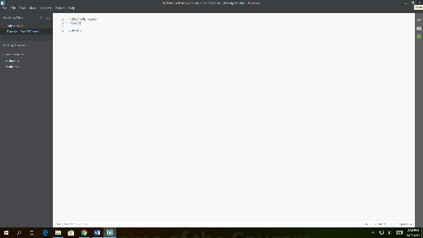I will be teaching you how to interpret an internal CSS script into your html code. The first step is to have an already started html script like this…

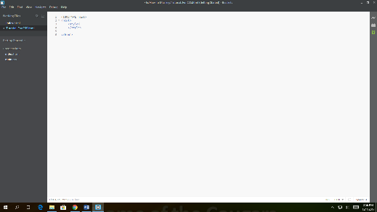Next add a simple <style></style> placed anywhere in your code like so…

Now you must begin to wright your CSS. First you must tell the webpage which “ID” you will be targeting. Like so.

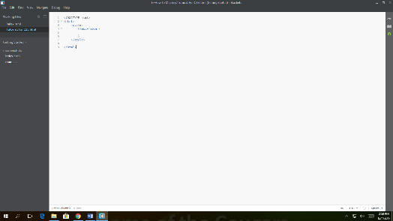

Now, add specifics to customize aspects of your website. Make sure to add the ID to the specified code you want your new CSS script to work on Here is an example of with CSS…

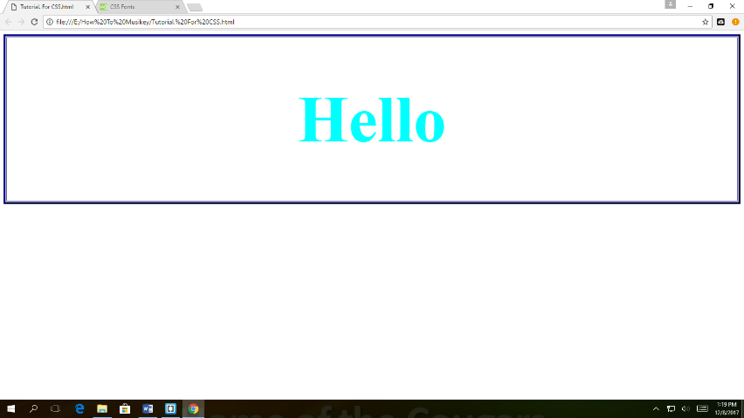

And without CSS

